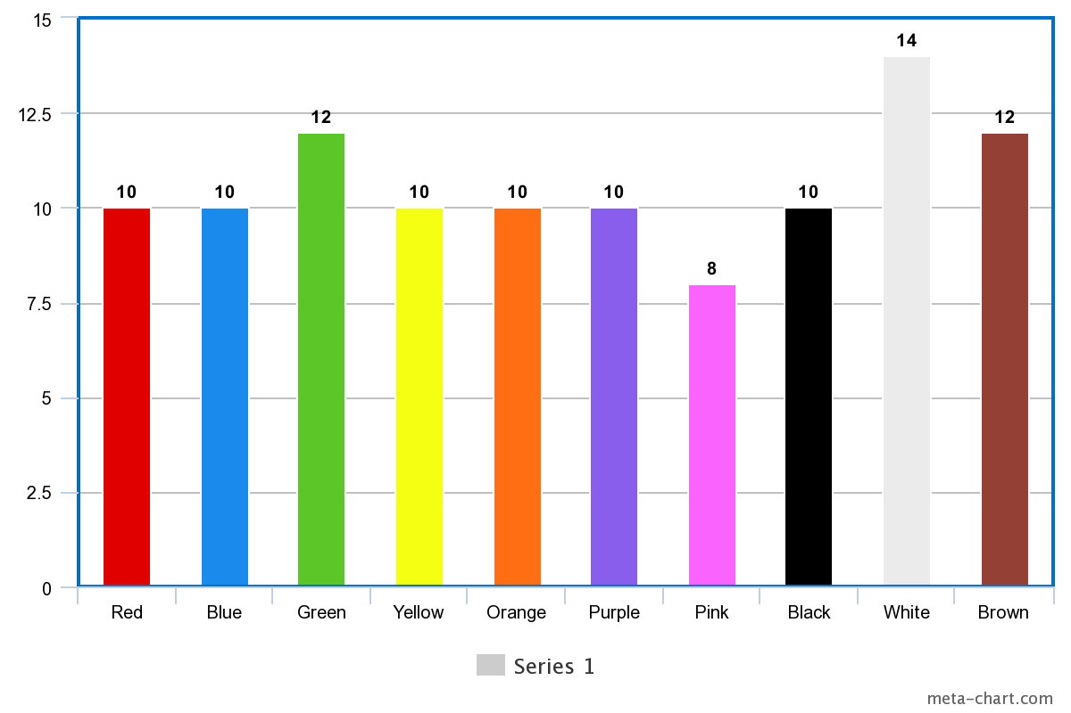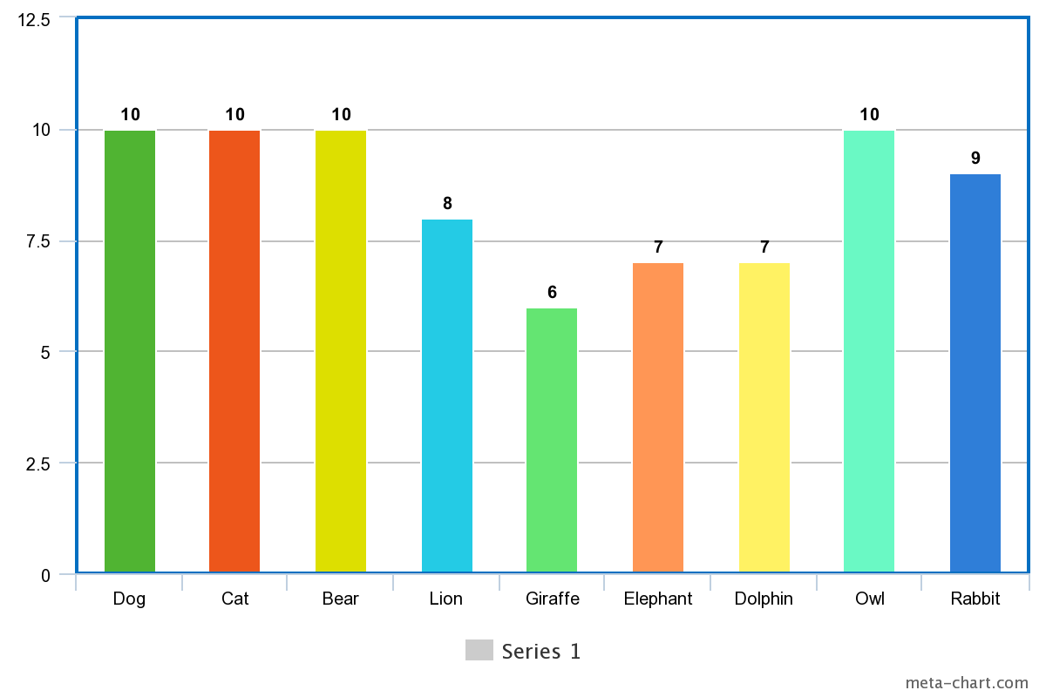

The red dog ran across the park, its fur shining in the sunlight.

The dog sniffed around the museum grounds at noon, looking for a shady green spot.

The dog's collar stood out against its red fur as it roamed the city at noon.

I saw a red cat sitting calmly by the river, watching the water flow by.

A brown bear wandered into the forest, blending into the brown hues of the trees.

The lion's roar could be heard at dawn as the savannah woke up.

A red giraffe at the zoo stretched its long neck to nibble on green leaves.

We saw a lion during our safari trip at noon, its mane stark against the yellow grass.

A group of dolphins leaped out of the water at the beach, splashing into the blue sea.

At twilight, an owl hooted from atop a tree in the park, its silhouette barely visible.

A rabbit hopped across the farm, its white fur contrasting with the brown earth.

The morning sky was a soft pink, much like the newborn giraffes at the zoo.

The elephant noticed the orange hue of the setting sun reflected on the windows of the library.

A black cat disappeared into the shadows of the museum at midnight.

The green forest was home to many animals, including a quiet rabbit.

At midnight, green rabbits foraged quietly in the forest.

The river where the elephant lived glistened under the afternoon sun, looking like a ribbon of blue.

I noticed a red owl in the park, standing out against the foliage.

A brown dog played fetch on the beach, its fur covered in sand.

The rabbit thought that white walls of the school seemed to glow in the bright noon light.

The desert owl turned a shade of purple during the evening as the sun dipped below the horizon.

By dawn, the mountain was bathed in a pink light, creating a magical atmosphere for the giraffe.

A dolphin was spotted in the river at mid-morning, an unusual but exciting sight.

In the evening, the desert lion looked orange, reflecting the colors of the setting sun.

At night, the forest became a place of mystery, the blackness almost impenetrable for the giraffe to proceed.

The yellow walls of the library seemed to brighten the mid-morning hours and the dolphins swimmed around happliy.

The farm animals settled down for the night, with the owl watching from its perch.

The pink flowers outside the museum looked extra bright against the green of the owls.

I met a friendly cat at the school, its orange fur bright and soft.

A black bear was seen ambling through the mountain region at noon.

During the afternoon, the park was filled with people and the sound of a dog barking.

The river reflected the blue sky, looking clear and calm by the afternoon as the elephants bathed in it.

At twilight, the desert lion’s mane took on a red hue, as if it caught fire.

A giraffe at the farm stretched high to reach the purple leaves on the trees.

The blue dolphin at the beach became the children's favorite attraction.

A white owl in the forest became a ghostly figure in the evening light.

At midnight, the black sky over the mountain was dotted with stars.

The yellow sun of the morning made the river look like a golden path for the dolphin to swim.

The pink dawn was a quiet time at the farm, with all the animals waking up.

A red apple fell in the park, promptly chased by a hungry rabbit.

At the beach, the sand turned a golden yellow under the high noon sun as the dolphins swam to the shore.

The giraffe's brown spots were a hit with the children visiting the zoo.

A purple flower in the forest attracted a curious cat.

At the farm, a dog joyfully chased after the orange hues of the setting sun.

The river was a dark blue in the twilight, mirroring the evening sky.

A black bear in the forest looked for honey at dawn, undisturbed by the morning light.

The white lion at the zoo seemed to prefer resting under the green shade during the afternoon.

A white rabbit in the schoolyard became a beloved pet for the students.

The blue waves at the beach were calming to watch during the late night.

At the library, the brown shelves were filled with books as old as time.

The mountain at twilight looked like a silhouette against the purple sky.

A black dog wandered the park at night, looking for a place to rest.

The green grass of the farm was dewy and fresh in the morning.

The desert at noon was a vast expanse of yellow, shimmering under the sun.

An orange giraffe nibbled on a flower in the school garden at mid-morning.

The library seemed magical at dawn, with the soft pink light filtering through the windows.

The museum at night seemed to hold secrets, like a cat lurking in the shadows.

The forest at evening was a symphony of sounds, with the owl joining in.

A white dog chased waves on the beach at morning, full of energy.

The park was filled with yellow dandelions, a perfect place for a rabbit to hide.

At the farm, a brown rabbit hopped happily during the afternoon.

The river at noon was a busy place, with dogs playing and children laughing.

A purple owl in the zoo entertained visitors all day, echoing their words.

The beach looked lovely in the evening, with the setting sun turning the sand orange.

The black cat at the library found a cozy spot to nap by the window at mid-morning.

In the desert, the yellow bear's fur contrasted with the brown ground at twilight.

The purple dusk made the mountain seem even more majestic.

At the school, the morning sun turned the windows pink with its warm glow.

The museum walls, painted a stark white, were bright against the noon sky.

A rabbit at the farm enjoyed the cool of the evening, nibbling on green grass.

The red hues of dawn gave the beach an otherworldly appearance.

A black bear in the forest became a silhouette against the night sky.

The yellow sun of the afternoon warmed the park, where children played games.

The mountain at midnight was quiet, with the stars twinkling above the white snowcaps.

The green foliage of the forest made for a beautiful backdrop at the zoo.

The orange sunset at the beach drew a crowd, with the dolphins playing offshore.

At the library, the white pages of the books turned purpleish under the warm mid-morning light.

The purple flowers at the school garden attracted a busy bee at dawn.

The red rabbit in the forest blended into the brown earth at evening.

A blue dolphin lived near the farm, its colors bright in the morning sun.

At noon, the desert owl looked like a canvas of orange and brown.

The white sands of the beach glistened under the midday yellow sun.

A red cat lounged in the park, its fur soaking up the afternoon heat.

The school's white walls reflected the pink of the early morning sky onto the elephant's eyes.

In the evening, the green leaves in the forest seemed to glow around the elephant.

At night, the farm was a peaceful place, the barn casting a black shadow on the ground.

The blue sky at dawn made the mountain lion seem even taller.

The yellow bus stopped in front of the school, its color vibrant against the morning quiet.

The brown dog's bark echoed through the empty museum at mid-morning.

The green grass at the park shimmered with dew in the early afternoon.

The orange sun cast a warm glow over the river at evening.

The black night was filled with the sound of an owl in the forest.

The lion's mane at the zoo was a deep shade of brown, matching the earth.

The purple twilight sky gave the desert elephant a serene ambiance.

At the farm, the white chicken coop stood out in the bright noon sun.

The white cat became a ghostly figure as it strolled the library at dusk.

A green cat blended into the grass at the park by mid-morning.

At the beach, a blue cat caught a fish from the river at noon.

At night, a pink bear became a beloved sight in the library during a special story time.

At dusk, white bears became almost indistinguishable from the snowy landscape at the museum.

The morning light caught the shimmer of a blue bear's fur in the city.

At midnight, the orange bear foraged through the forest looking for a late snack.

The purple bear's presence at the school caused quite a stir at noon.